

InstallShield®

Tuner OEM 3.5

Setup

Specification

Owner(s) Jigar Desai

Last Updated 8/29/2002 05:39:00 PM

File Name 0000.doc

© 1999 InstallShield Software Corporation. All rights reserved.
THIS IS PRELIMINARY DOCUMENTATION. The information contained in this document represents the current view of InstallShield Software Corporation on the issues discussed as of the date of publication. Because InstallShield must respond to changing market conditions, it should not be interpreted to be a commitment on the part of InstallShield, and InstallShield cannot guarantee the accuracy of any information presented after the date of publication.
This BETA document is for informational purposes only. INSTALLSHIELD MAKES NO WARRANTIES, EXPRESS OR IMPLIED, IN THIS DOCUMENT.
Other product or company names mentioned herein may be the trademarks of their respective owners.
InstallShield Software Corporation • 900 National Parkway • Schaumburg, Illinois 60173-5108

Table of Contents

^{1.0 Abstract} 3
^{2.0 Requirements} 3
3.0 Features Reserved for Future Versions 4
^{4.0 Limitations} 4
^{5.0 Issues} 4
^{6.0 Revision History} 4

^{1.0 Abstract}
This documents outlines the requirements for the InstallShield Tuner OEM 3.5 setup.

^{2.0 Requirements}

- Perform an upgrade from previous versions of Tuner, IPWI and Express.
- Have a new product code and package code.
- Validate the serial number in the UISequence and ExecuteSequences.
- Launch the registration wizard at the end of the install.
- Setup will consists of the following:
    - 1 feature with 2 sub features. The top level feature will include files require for Full and eval editions.
    - A merge module - InstallShield_Tuner.msm with all the tuner files.

- All features will be installed on the local machine.
- INSTALLDIR will be installed in <ProgramFiles>\InstallShield\Tuner

Typical Shortcuts are shown here.

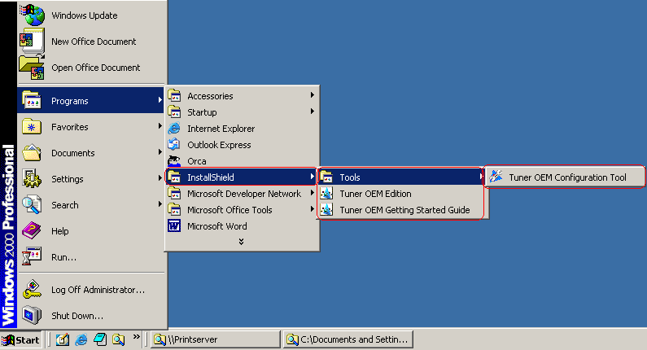

- Launch the registration wizard at the end of the install.

3.0 Features Reserved for Future Versions

^{4.0 Limitations}

^{5.0 Issues}
- What should be the name of Tuner OEM 3.5?
Right now the product name is InstallShield Tuner OEM.

- What Serial Numbers should be accepted?
Right now we are using AdminStudio Pelican serial numbers for internal testing.

- Which EULA should be used with Tuner OEM 3.5? Should we use different EULA since this is OEM product?

- Coexistence:
Should it coexist with AdminStudio Pelican or any older version of Tuner?

- Should we do major upgrade from old Tuner realeases?

^{6.0 Revision History}

Date | Author | Change Reference
08/22/2002 | Jigar Desai | Initial Draft

